MongoDB model for Football Schema
The following sections show sample data for the manager, player and club statistics, milestone goals as collections of documents as designed in the Football schema using mongo DB. The sample screenshots are taken from the mongo DB Compass for better view of the document structure.

ManagerStats collection
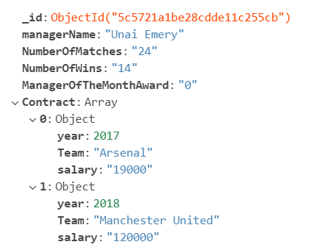
ManagerStats collection properties.
managerName – stores the manager’s name
NumberOfMatches, NumberOfWins - total number of matches played and won under the guidance of the manager
ManagerOfTheMonthAward – an array of embedded documents containing the year and month for each award won.
Contract - an array of embedded documents containing the contract year, team and salary for each contract entered.

clubStats collection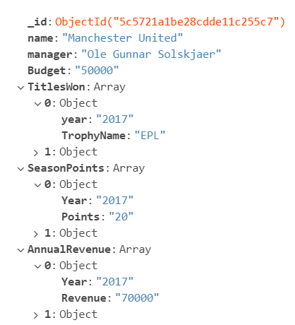
clubStats collection properties:
name – indicates the club name
manager – stores the manager’s name
Budget – stores the budget of the club
TitlesWon – an array of embedded documents containing the year and name of each trophy/title won.
SeasonPoints - an array of embedded documents containing the year and total points gained for each season participated.
AnnualRevenue - an array of embedded documents containing the year and revenue generated for each year.

MilestoneGoalscollection:

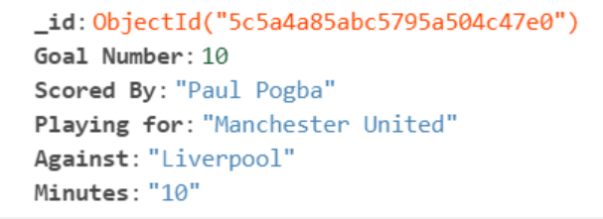
MilestoneGoalscollection properties:
Goal Number – indicates the milestone goal
Scored By – player’s name who scored the milestone goal
Playing for - player’s team name
Against – indicates the team against which the goal was scored
Minutes – The minute at which the goal was scored

playerStats collection:
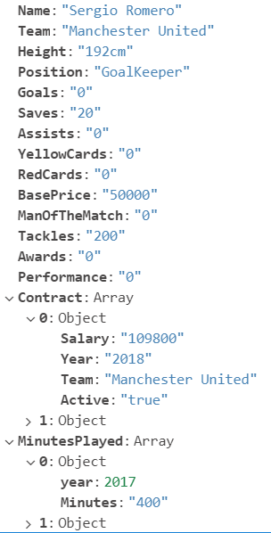
playerStats collection properties:
name, Height – indicates the player’s name, height
Team – stores the team to which the player belongs
Position – indicates the role of the player in the matches
Goals, Saves, Assists, Tackles – indicate the total number of goals scored/saves made, assists and tackles made by the player over his tenure in the league
RedCards, YellowCards – Indicates the total number of red/yellow cards received till date
ManOfTheMatch – total number of the award received by the player till date
BasePrice – indicates the base price of the player’s market value
Performance – calculated value based on the player’s overall performance in the games
MinutesPlayed - an array of embedded documents containing the year and total minutes played in each year.
Contract - an array of embedded documents containing the contract year, team and salary for each contract entered.

